DVLA GUIDANCE:

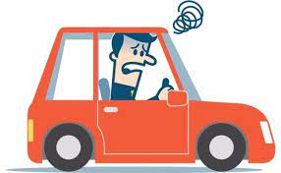

We have recently received a few questions regarding DVLA fitness to drive after diagnosis or treatment for acoustic neuroma/vestibular schwannoma.

The DVLA make it clear that there is no need to inform them of the diagnosis and no need to stop driving unless there is disabling giddiness (dizziness). If you drive a group 2 vehicle (see below), the information is the same unless there are tumours on both sides (usually only in cases of NF2/neurofibromatosis type II).

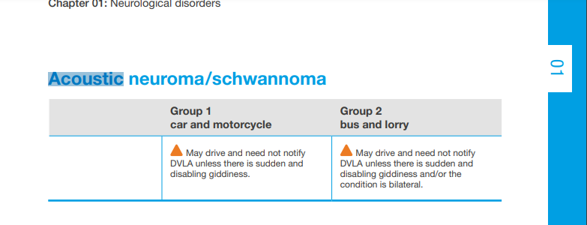

The DVLA guidance specifically for acoustic neuroma, only mentions diagnosis. If you have had treatment, either with surgery or radiotherapy (SRS or fractions of radiotherapy), we look at the guidance for similar “benign” tumours that are in the anatomical “infratentorial” area.

The guidance is similar in that there is no need to inform the DVLA and you may resume driving on recovery (it is usually appropriate to drive when you are able to turn head fully, not feel dizzy and are able to do a safe emergency stop) assuming there are no new visual issues such as double vision, no complications such as stroke, hydrocephalus or limb weakness.

If you drive a group 2 vehicle (bus/lorry etc) then you **MUST** notify the DVLA following either treatment but you are able to resume driving on recovery.

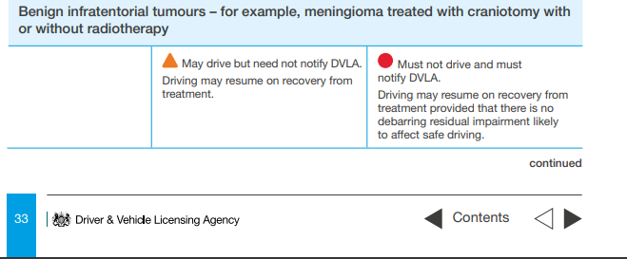

If you have disabling dizziness/giddiness, you should refrain from driving until this stops and there is a state of stability.

**If you have had an associated complication, different rules may apply. There are varying levels of advice and it is likely you will need to speak to your treating team or the DVLA directly to clarify.**

Some examples include:

**Stroke/bleed**: May need to notify the DVLA and may need to refrain from driving for a period until associated neurological symptoms have resolved.

**Meningitis:** Must not drive and may need to inform the DVLA. If no seizures, may resume driving without notifying DVLA once fully recovered and no residual disability.

**Seizures:** There are varying levels of seizure classification. You must not drive and must inform the DVLA. Depending on the type of seizure, what provoked it and whether there has been more than one will determine how long you are unable to drive for. It is usually a minimum of 6 months but can be longer.

**Hydrocephalus:** Hydrocephalus (build up of water on the brain) treated with a ventriculoperitoneal shunt (VP shunt), 3rd ventriculostomy or an external ventricular drain (EVD). Must not drive and must notify the DVLA. There is usually a 6 month period before you can drive again.

**Diplopia (double vision):** Must not drive and must notify the DVLA. If there is evidence that the double vision can be controlled (for example with glasses/prism or a patch) or the double vision has been stable for 6 months and the ophthalmologists can report there have been adequate adaptations/compensations, driving may resume. We advise a visual assessment before commencing driving in this instance.

**Deafness:** Profound deafness only affects those who drive group 2 vehicles. The DVLA guidance for car drivers is that you may drive and do not need to inform the DVLA.

We would always suggest you inform your car insurance of the diagnosis as it is usually stipulated on most policies to inform about new medical conditions.

If you are unsure about your own driving status, please contact your team and/or the DVLA.